Orazio Lentini

Krunal Intwala

May 8, 2013

Mobile Web Application: Oraz

Project description:



**Oraz**

Oraz - A mobile web application created by Orazio Lentini and Krunal Intwala.

* Goal of Oraz is to assists users to purchase a camera or phone that takes great pictures.
* This application allows users to view and compare images taken by cameras or phones.
* Features include adding to favorites, deleting favorites, deleting all favorites, as well as controlling how many camera models and images are displayed.

Oraz - uses HTML5, jQuery Mobile, JavaScript with Backbone.js, CSS, flickr API, and phonegap.

* HTML5 is used to create the actual web page.
* jQuery is used for its integrated user interface.
* JavaScript with Backbone.js is used for routing, local storage, creating views, getting models, and getting images.
* CSS is used for custom style format.
* flicker API is to retrieve camera brands, camera models and images.
* phonegap is used to create the application file so it can run on the phone.

**Screen shots:**

Download Oraz:



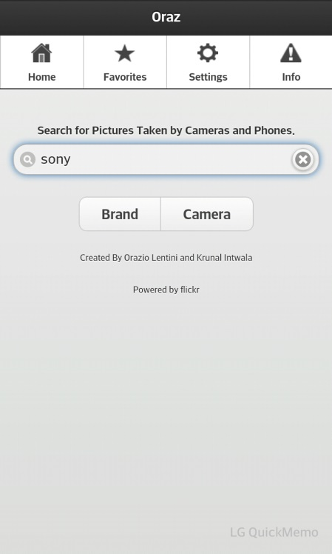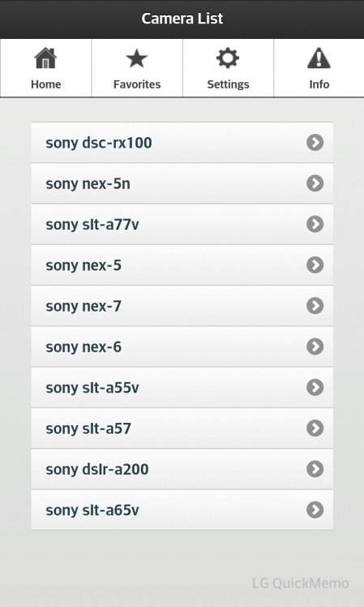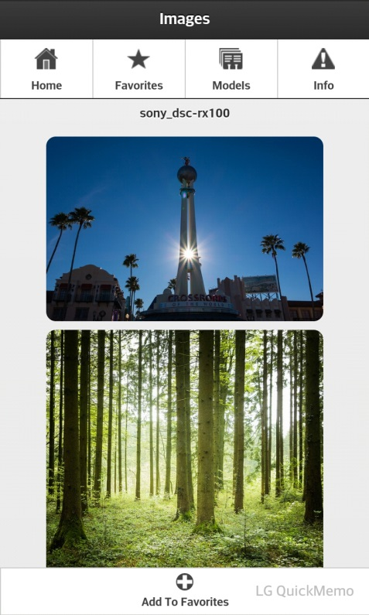

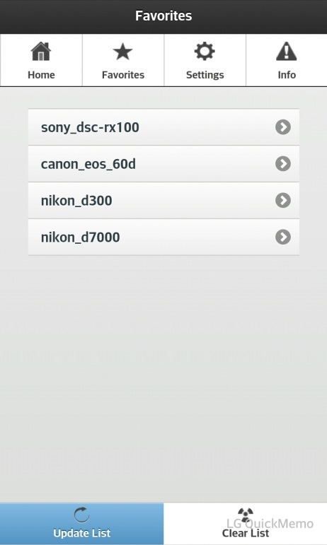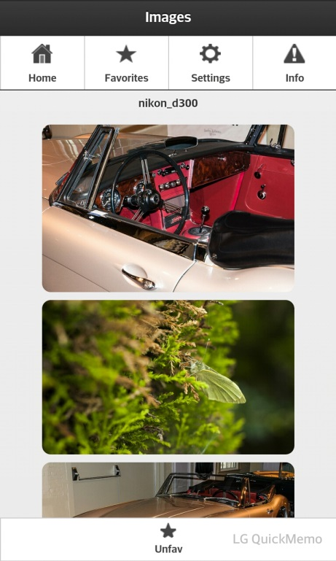 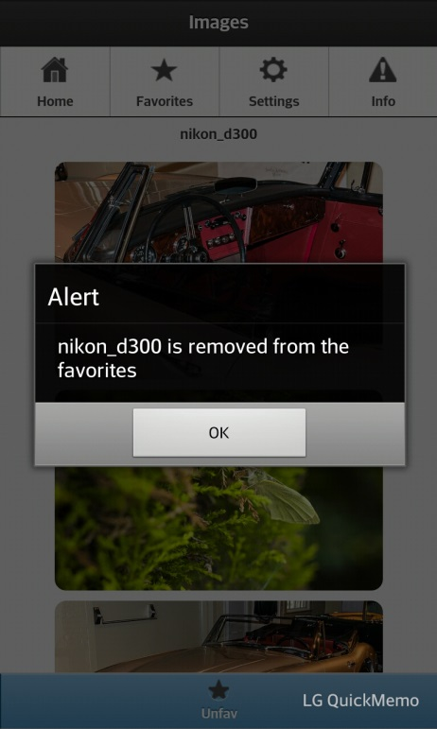

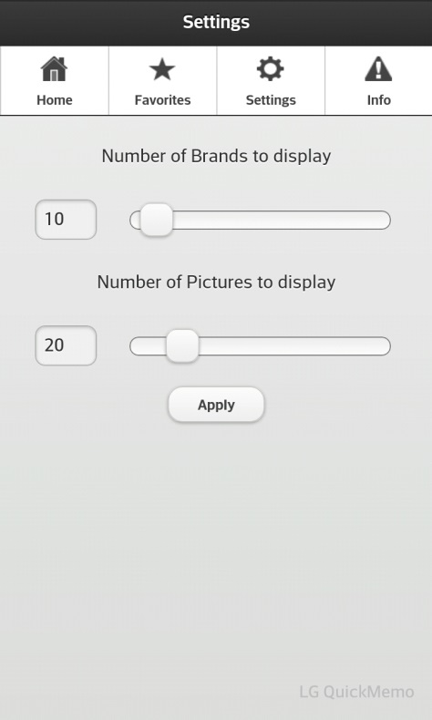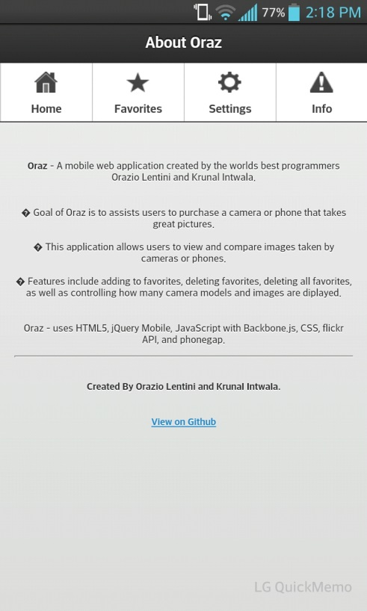

GitHub:

<https://github.com/OrazioLentini/ORAZ>

**List of application development contribution:**

|  |  |
| --- | --- |
| **Orazio Lentini** | **Krunal Intwala** |
| * flickerApi – JavaScript in application searching for models and photos * Local Storage * BackBone.js * User Interface Design * Documentation | * flickr API – HTML5 web site searching for photos and direct search on the app * Local Storage * BackBone.js * Phonegap * documentation |

Agile software development methodology was used.

* Each time we figured out something we would add it to our own files that we were working and then we tried to build upon it.
* We had list of items that we needed in our application, we weren’t restricted any one of them.
* Collectively we worked on it together for the most part of the application by meeting before every class.